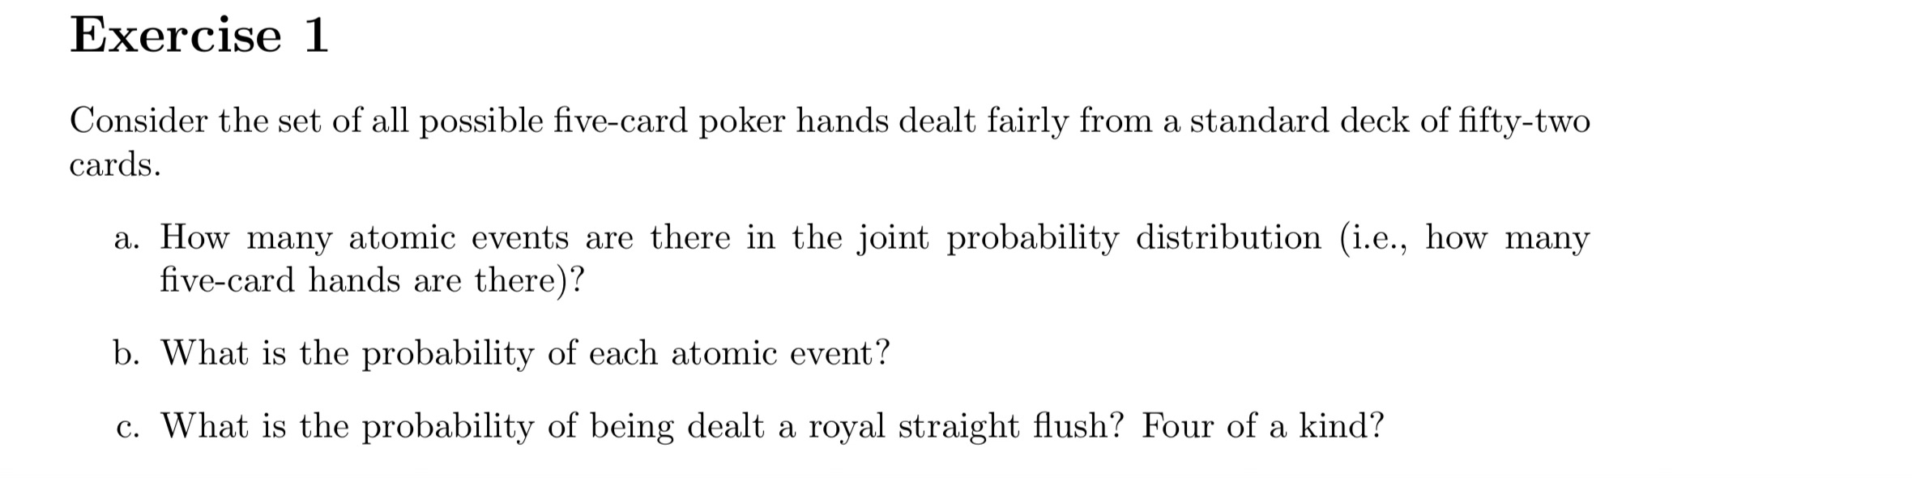

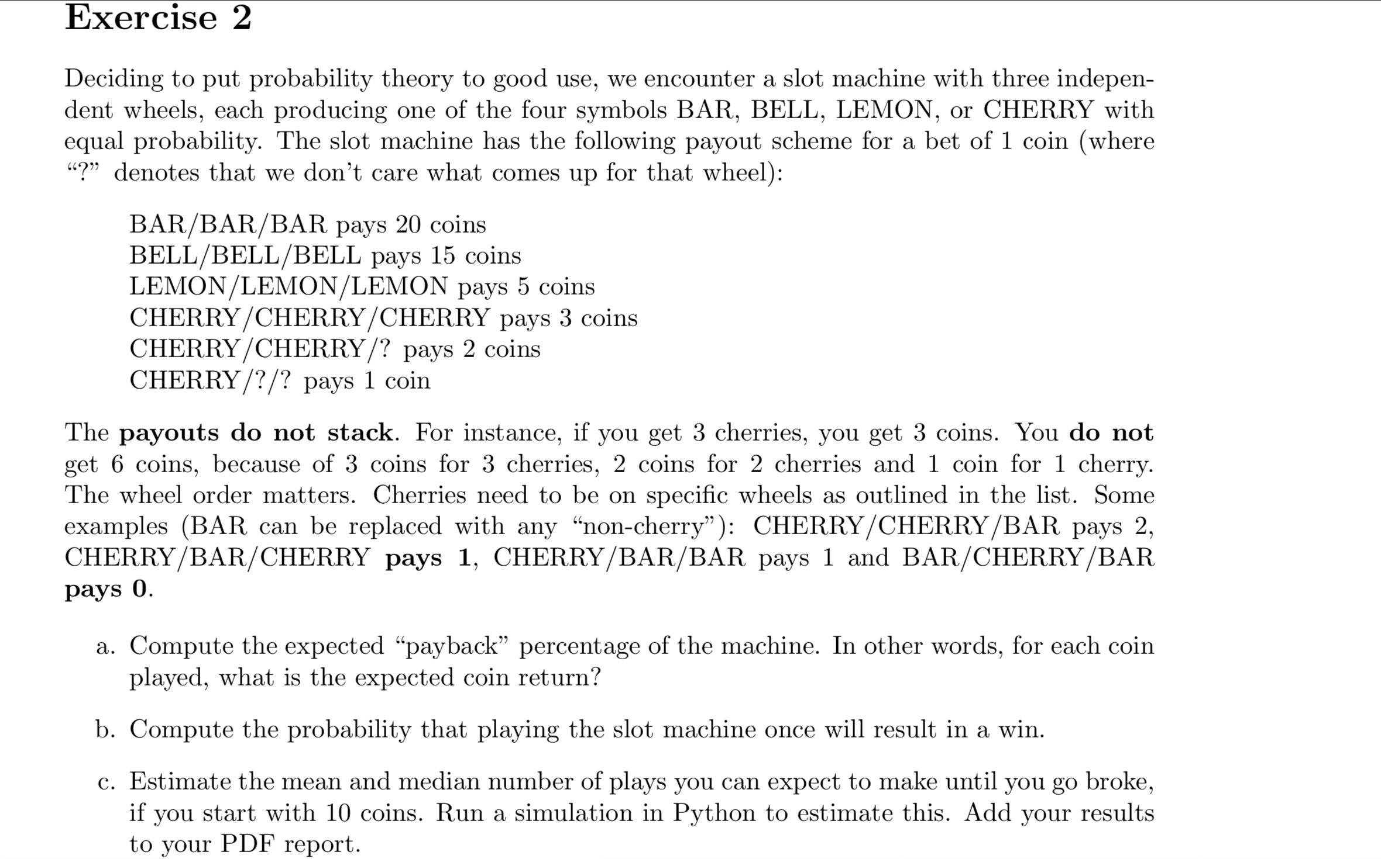

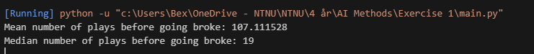

The mean being approximately 107 confirms our claim. The median tells us that before 19 plays (from 1 to 19), there is a 50% chance of going broke already, and the other half will go broke between 19 and the maximum number of plays, which depends on the luckiest outcomes in the trials.

# Exercise 3

The function can be created by getting random integers in a calendar year which is repeated N times. At each iteration if there are duplicate birthdays then it means we have at least two who share a birthday, so we increment our counter. We iterate this process once again a sufficient number of times (10000 times but theoretically as it approaches infinity but for most cases 10000x and 100000x is precise enough for our needs). (Shared birthday count / total iterations) then gives us an approximation of the probability. The answer as shown is N = 23



The proportion is the sum between N = 23 and 50 divided by the total results (40 + 1 = 41, including 10 and 50). According to our simulation 68% of the numbers in range of 10 to 50 have at least a 50% chance of containing duplicate birthdays.



On average he should get 2370 people to join his group before he can fulfill his mission. This is also done like the previous task but with the difference being that it follows the instructions 1, 2, 3 shown in the task. We can afford to simulate more iterations here as the calculations are relatively less intensive than the previous task.